Join us for the 6th Annual
“Run For Red”
Fatima FCCLA 5K Walk/Run

Saturday, September 30, 2017 at 8:00 a.m.
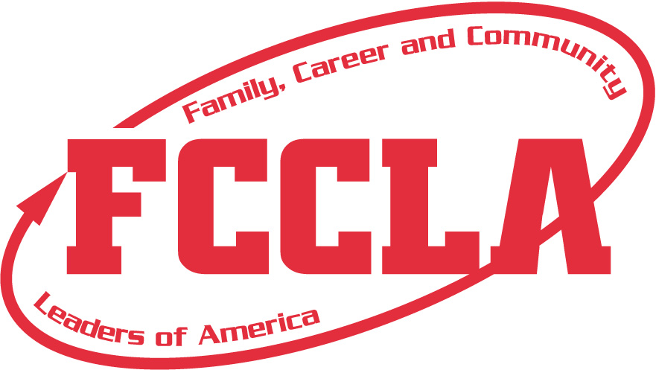

Entry Fees:
Early Registration: $25.00 (Before September 14, shirt included)
Race Day: $25.00, but no shirt

Sponsored by:
Rudroff Bus Company
(all proceeds benefit Fatima FCCLA)
Registration form and map can be found at http://libbertfcs.weebly.com (FCCLA/5K Link) or contact an FCCLA member.

