### Items

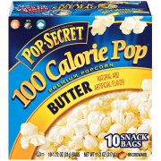$4/18

10 bags

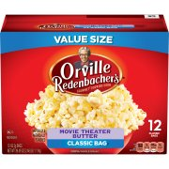$5.20

12 bags

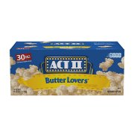$11.87

30 bags

### Unit Price

### Best Deal

### Hy-Vee Greek Yogurt$2.99

32 oz.

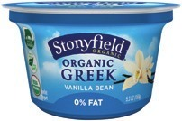$1.25

5.3 oz.

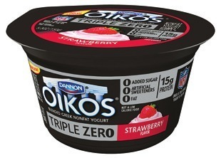$1.00

4 oz.

### Malt-O-Meal Cereal$1.99

30.6 oz.

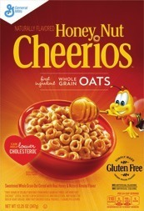$2.50

13 oz.

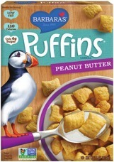$2.60

14 oz.

### https://i5.walmartimages.com/asr/571dc31c-2c87-478b-a3ff-48cf0f3ade8a_3.52812c2eb5378aa26ffabb206f3ebc88.jpeg?odnHeight=180&odnWidth=180&odnBg=ffffff$2.00

21 oz.

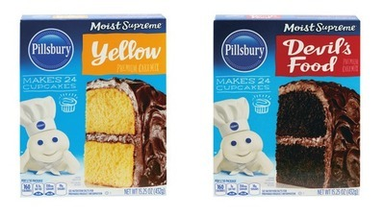$1.12

15.25 oz.

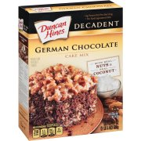$2.78

21 oz.

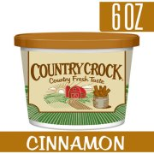$1.49

Gerbes

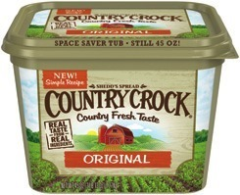$2.99

45 oz.

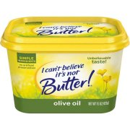$1.99

15 oz.

### Hyvee

### Ground Beef$5.97

3 lb. roll

**Schnucks**

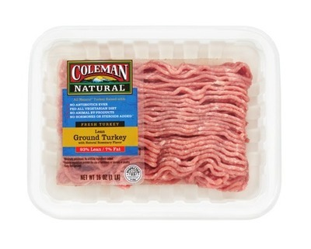$3.99

16 oz.

**Target**

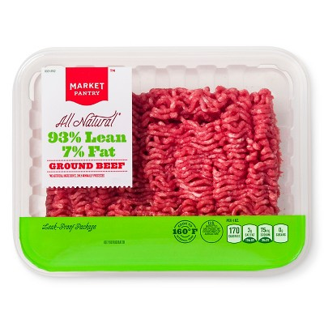$4.25

12 oz.